**20.LIBRARY MANAGEMENT SYSTEM**

USE CASE DIAGRAM:

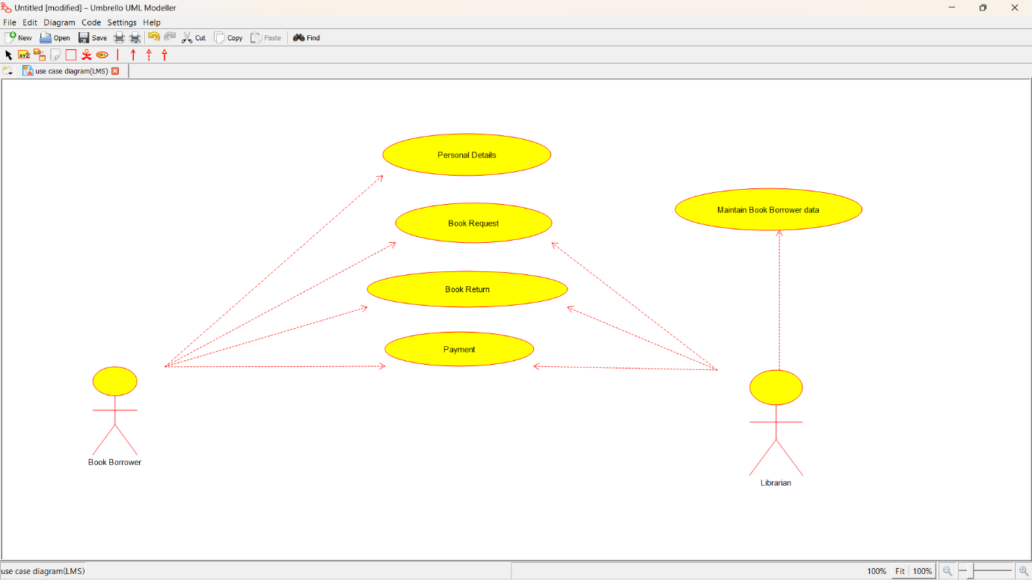

CLASS DIAGRAM:

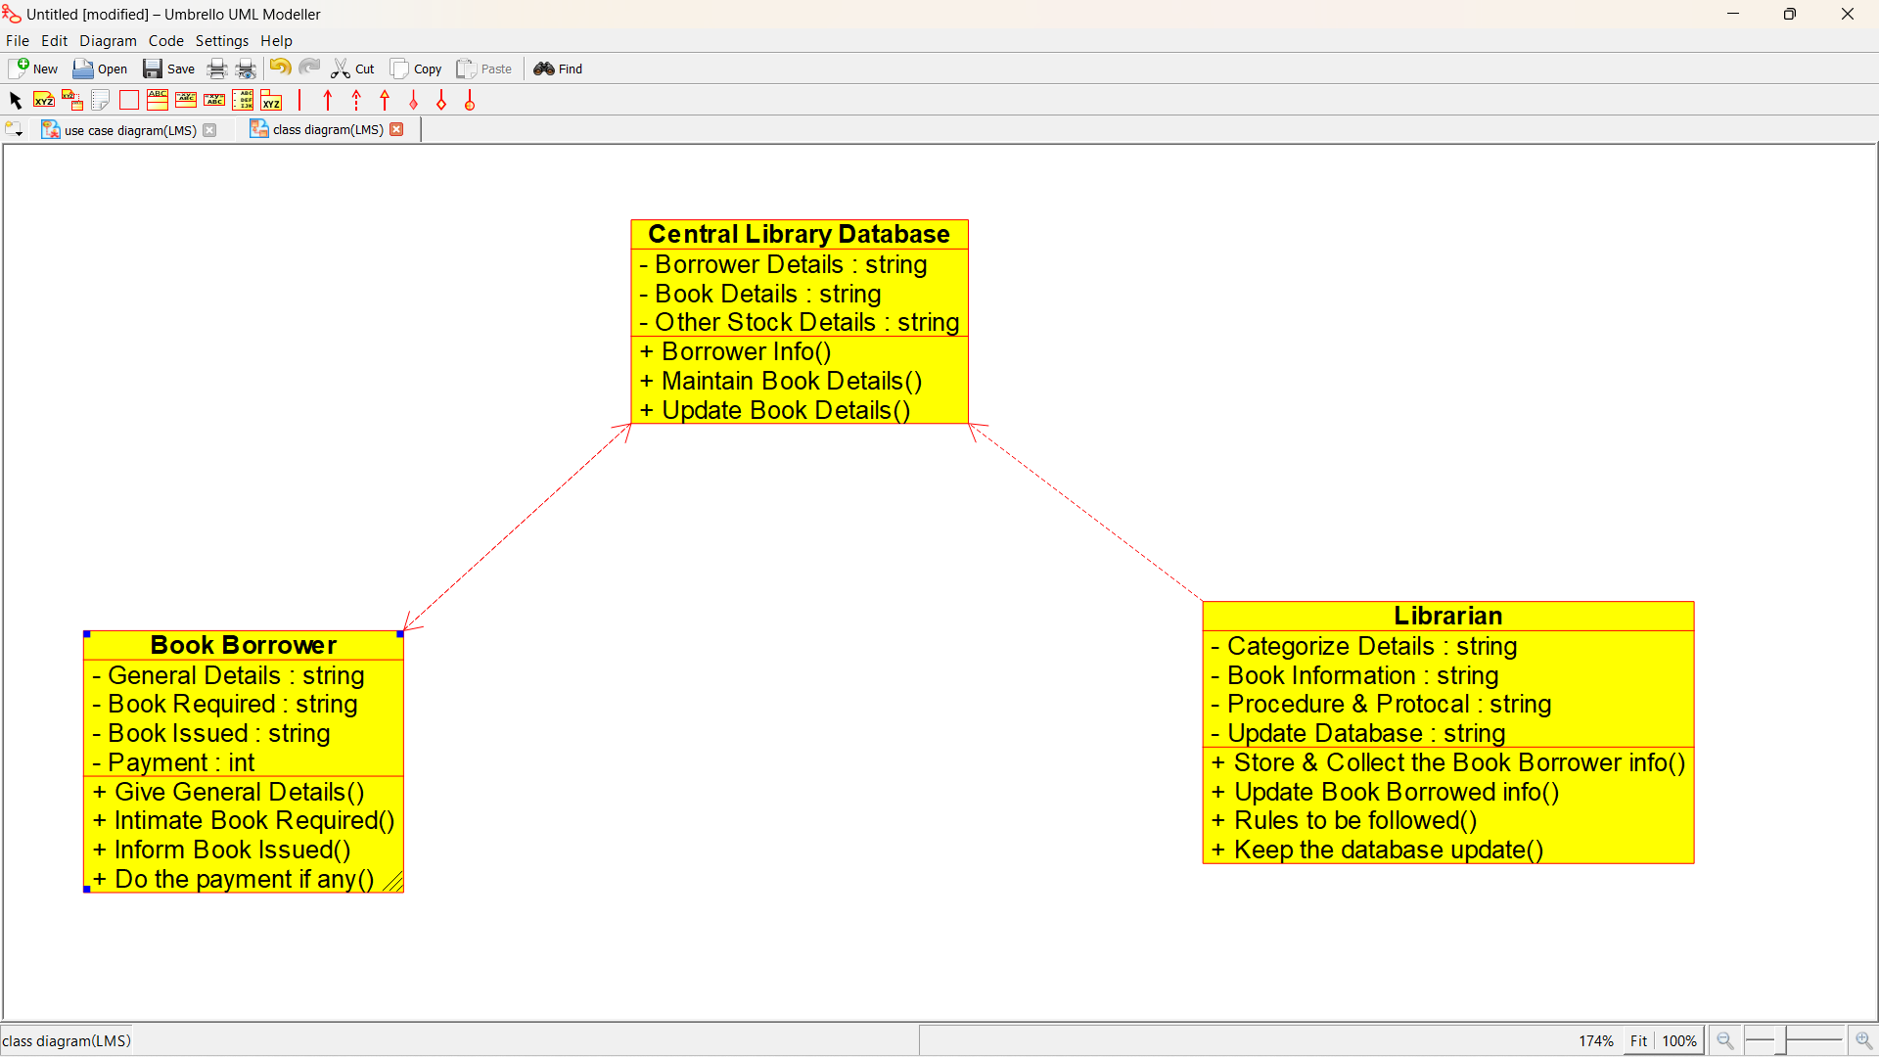

ACTIVITY DIAGRAM:

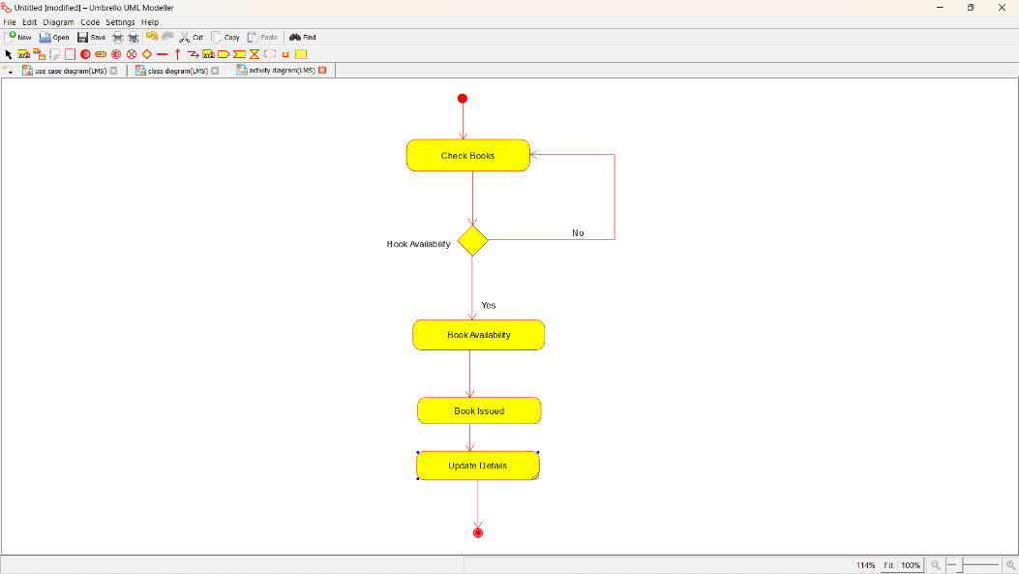

SEQUENCE DIAGRAM:

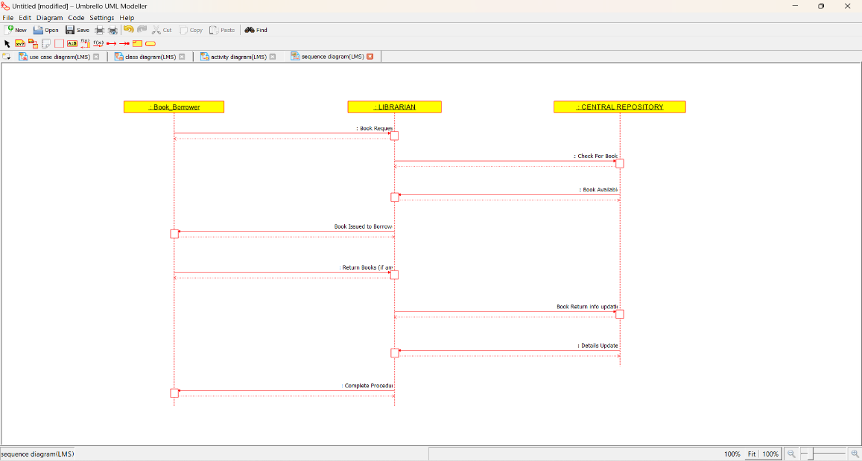

COLLABORATION DIAGRAM:

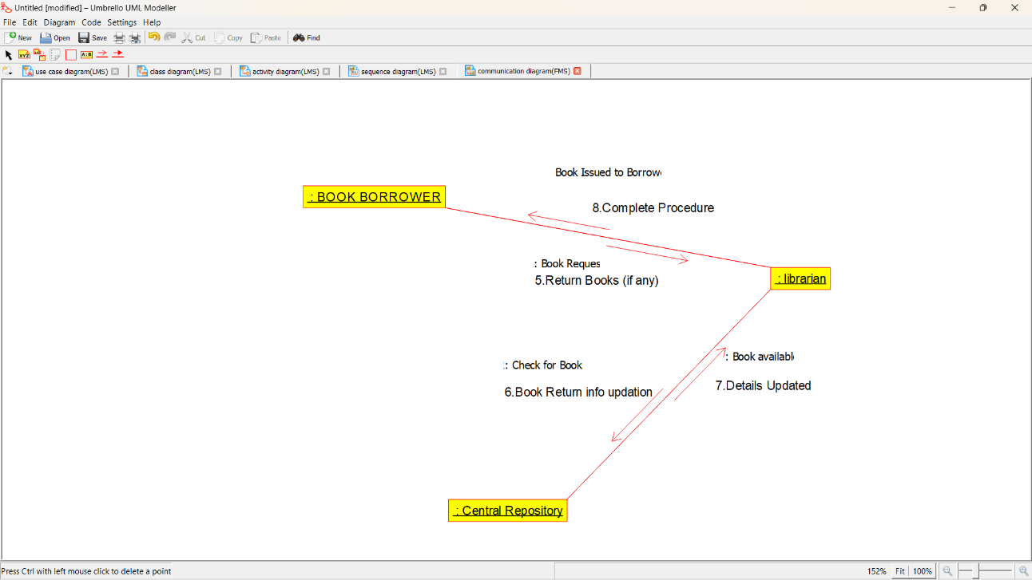

STATE CHART DIAGRAM:

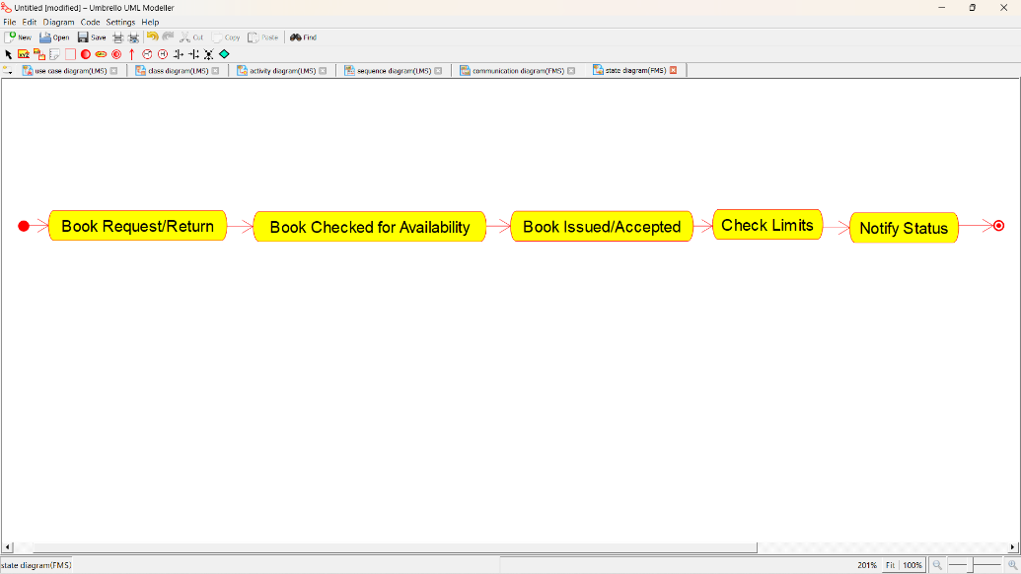

COMPOMEMT DIAGRAM:

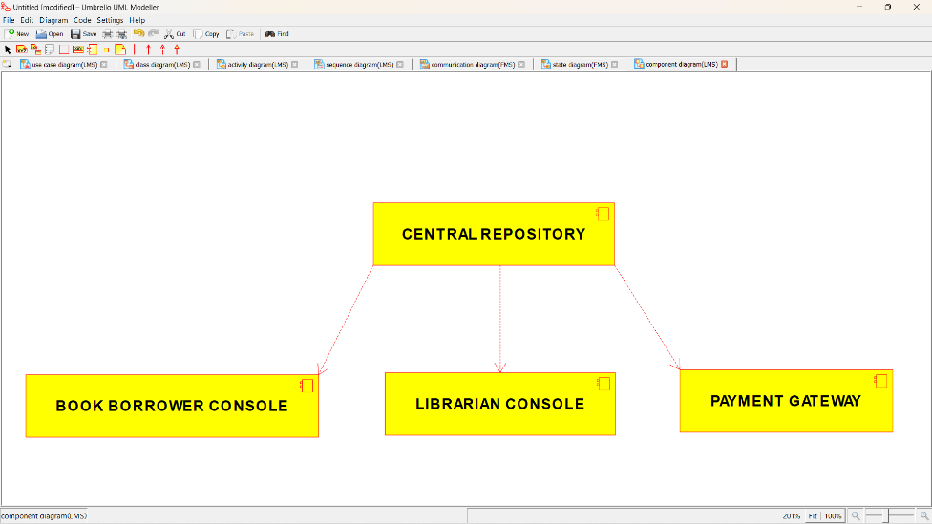

DEPLOYMENT DIAGRAM:

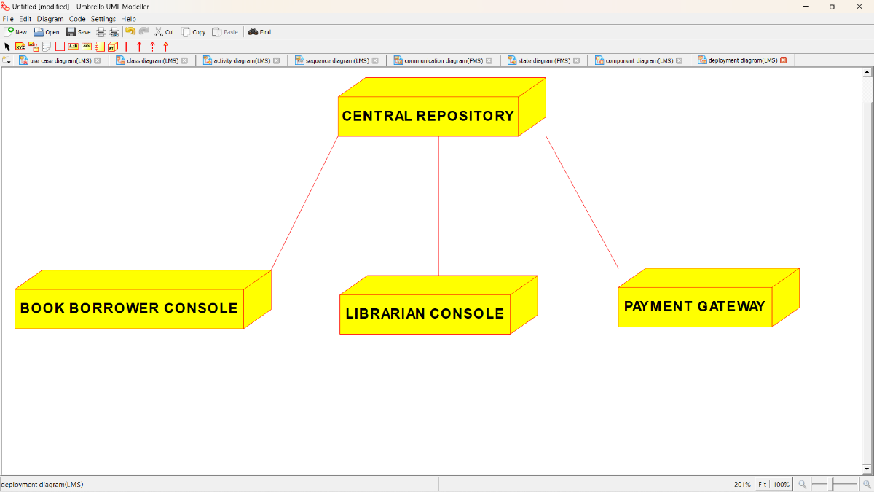

***PROGRAM CODING:***

**/\*\***

**\* Class Central_Library_Database**

**\*/**

**public class Central_Library_Database {**

**//**

**// Fields**

**//**

**private String Borrower_Details;**

**private String Book_Details;**

**private String Other_Stock_Details;**

**//**

**// Constructors**

**//**

**public Central_Library_Database () { };**

**//**

**// Methods**

**//**

**//**

**// Accessor methods**

**//**

**/\*\***

**\* Set the value of Borrower_Details**

**\* @param newVar the new value of Borrower_Details**

**\*/**

**private void setBorrower_Details (String newVar) {**

**Borrower_Details = newVar;**

**}**

**/\*\***

**\* Get the value of Borrower_Details**

**\* @return the value of Borrower_Details**

**\*/**

**private String getBorrower_Details () {**

**return Borrower_Details;**

**}**

**/\*\***

**\* Set the value of Book_Details**

**\* @param newVar the new value of Book_Details**

**\*/**

**private void setBook_Details (String newVar) {**

**Book_Details = newVar;**

**}**

**/\*\***

**\* Get the value of Book_Details**

**\* @return the value of Book_Details**

**\*/**

**private String getBook_Details () {**

**return Book_Details;**

**}**

**/\*\***

**\* Set the value of Other_Stock_Details**

**\* @param newVar the new value of Other_Stock_Details**

**\*/**

**private void setOther_Stock_Details (String newVar) {**

**Other_Stock_Details = newVar;**

**}**

**/\*\***

**\* Get the value of Other_Stock_Details**

**\* @return the value of Other_Stock_Details**

**\*/**

**private String getOther_Stock_Details () {**

**return Other_Stock_Details;**

**}**

**//**

**// Other methods**

**//**

**/\*\***

**\*/**

**public void Borrower_Info()**

**{**

**}**

**/\*\***

**\*/**

**public void Maintain_Book_Details()**

**{**

**}**

**/\*\***

**\*/**

**public void Update_Book_Details()**

**{**

**}**

**}**

**/\*\***

**\* Class Book_Borrower**

**\*/**

**public class Book_Borrower {**

**//**

**// Fields**

**//**

**private String General_Details;**

**private String Book_Required;**

**private String Book_Issued;**

**private int Payment;**

**//**

**// Constructors**

**//**

**public Book_Borrower () { };**

**//**

**// Methods**

**//**

**//**

**// Accessor methods**

**//**

**/\*\***

**\* Set the value of General_Details**

**\* @param newVar the new value of General_Details**

**\*/**

**private void setGeneral_Details (String newVar) {**

**General_Details = newVar;**

**}**

**/\*\***

**\* Get the value of General_Details**

**\* @return the value of General_Details**

**\*/**

**private String getGeneral_Details () {**

**return General_Details;**

**}**

**/\*\***

**\* Set the value of Book_Required**

**\* @param newVar the new value of Book_Required**

**\*/**

**private void setBook_Required (String newVar) {**

**Book_Required = newVar;**

**}**

**/\*\***

**\* Get the value of Book_Required**

**\* @return the value of Book_Required**

**\*/**

**private String getBook_Required () {**

**return Book_Required;**

**}**

**/\*\***

**\* Set the value of Book_Issued**

**\* @param newVar the new value of Book_Issued**

**\*/**

**private void setBook_Issued (String newVar) {**

**Book_Issued = newVar;**

**}**

**/\*\***

**\* Get the value of Book_Issued**

**\* @return the value of Book_Issued**

**\*/**

**private String getBook_Issued () {**

**return Book_Issued;**

**}**

**/\*\***

**\* Set the value of Payment**

**\* @param newVar the new value of Payment**

**\*/**

**private void setPayment (int newVar) {**

**Payment = newVar;**

**}**

**/\*\***

**\* Get the value of Payment**

**\* @return the value of Payment**

**\*/**

**private int getPayment () {**

**return Payment;**

**}**

**//**

**// Other methods**

**//**

**/\*\***

**\*/**

**public void Give_General_Details()**

**{**

**}**

**/\*\***

**\*/**

**public void Intimate_Book_Required()**

**{**

**}**

**/\*\***

**\*/**

**public void Inform_Book_Issued()**

**{**

**}**

**/\*\***

**\*/**

**public void Do_the_payment_if_any()**

**{**

**}**

**}**

**/\*\***

**\* Class Librarian**

**\*/**

**public class Librarian {**

**//**

**// Fields**

**//**

**private String Categorize_Details;**

**private String Book_Information;**

**private String Procedure_Protocal;**

**private String Update_Database;**

**//**

**// Constructors**

**//**

**public Librarian () { };**

**//**

**// Methods**

**//**

**//**

**// Accessor methods**

**//**

**/\*\***

**\* Set the value of Categorize_Details**

**\* @param newVar the new value of Categorize_Details**

**\*/**

**private void setCategorize_Details (String newVar) {**

**Categorize_Details = newVar;**

**}**

**/\*\***

**\* Get the value of Categorize_Details**

**\* @return the value of Categorize_Details**

**\*/**

**private String getCategorize_Details () {**

**return Categorize_Details;**

**}**

**/\*\***

**\* Set the value of Book_Information**

**\* @param newVar the new value of Book_Information**

**\*/**

**private void setBook_Information (String newVar) {**

**Book_Information = newVar;**

**}**

**/\*\***

**\* Get the value of Book_Information**

**\* @return the value of Book_Information**

**\*/**

**private String getBook_Information () {**

**return Book_Information;**

**}**

**/\*\***

**\* Set the value of Procedure_Protocal**

**\* @param newVar the new value of Procedure_Protocal**

**\*/**

**private void setProcedure_Protocal (String newVar) {**

**Procedure_Protocal = newVar;**

**}**

**/\*\***

**\* Get the value of Procedure_Protocal**

**\* @return the value of Procedure_Protocal**

**\*/**

**private String getProcedure_Protocal () {**

**return Procedure_Protocal;**

**}**

**/\*\***

**\* Set the value of Update_Database**

**\* @param newVar the new value of Update_Database**

**\*/**

**private void setUpdate_Database (String newVar) {**

**Update_Database = newVar;**

**}**

**/\*\***

**\* Get the value of Update_Database**

**\* @return the value of Update_Database**

**\*/**

**private String getUpdate_Database () {**

**return Update_Database;**

**}**

**//**

**// Other methods**

**//**

**/\*\***

**\*/**

**public void Store_Collect_the_Book_Borrower_info()**

**{**

**}**

**/\*\***

**\*/**

**public void Update_Book_Borrowed_info()**

**{**

**}**

**/\*\***

**\*/**

**public void Rules_to_be_followed()**

**{**

**}**

**/\*\***

**\*/**

**public void Keep_the_database_update()**

**{**

**}**

**}**